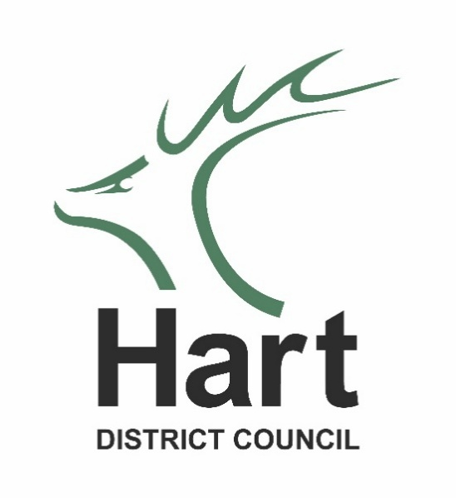

Improving Health and Wellbeing in Hart

Our Plan

2025 – 2028

CONTENTS
2 About the plan
3 What influences health and wellbeing
4 How Hart District Council can influence health and wellbeing
5 Where are we now?
6 Our approach to improving health and wellbeing
7 Health and wellbeing priorities | Active Lives
9 Health and wellbeing priorities | Preventing Poor Health
12 Health and wellbeing priorities | Access to Support & Information

About the plan
There are benefits for everyone if we stay fit and well. Healthy people generally have a better quality of life, more independence, are able to make more of their own choices, take an active part in their community and have the chance of a better life.
We are fortunate that many people in Hart experience a good quality of life and positive health and wellbeing. However, we know that this is not everyone’s experience and that more could be done to improve health and wellbeing in Hart’s communities.
We want to work with our partners and communities to deliver improved health and wellbeing outcomes for everyone in Hart.
This plan sets out the health and wellbeing priorities the council will focus on between 2025 and 2028 and the approach we will take to delivering these.
Our priorities have been guided by:
- What we know about the health and wellbeing of Hart’s communities
- Related plans and strategies including the Council’s Corporate Plan, Hart’s Housing Strategy 2026 – 2031, Hart’s Countryside and Wellbeing Strategy, the Hampshire Health and Wellbeing Board Strategy, the Hampshire Public Health Strategy, the NHS Long Term Plan, and other local health and care plans
- Conversations with our services and local organisations and groups through our Here for Hart partnership

The priorities reflect areas where we feel there is potential for the Council to have the greatest impact on improving health and wellbeing, in collaboration with our partners and communities.

What influences health and wellbeing
Our health and wellbeing is shaped by many factors including the lifestyle we follow, whether we have a job, how much money we have, the type of house we live in, how connected we are with family, friends and our local community and the healthcare we receive.
These factors can directly influence our health and wellbeing as well as impacting on our opportunities, choices and access to services, and 80% of these factors lie beyond clinical care (see Figure 1).
Mental and physical health should not be thought of separately. Physical health problems significantly increase the risk of poor mental health and wellbeing, and vice versa.
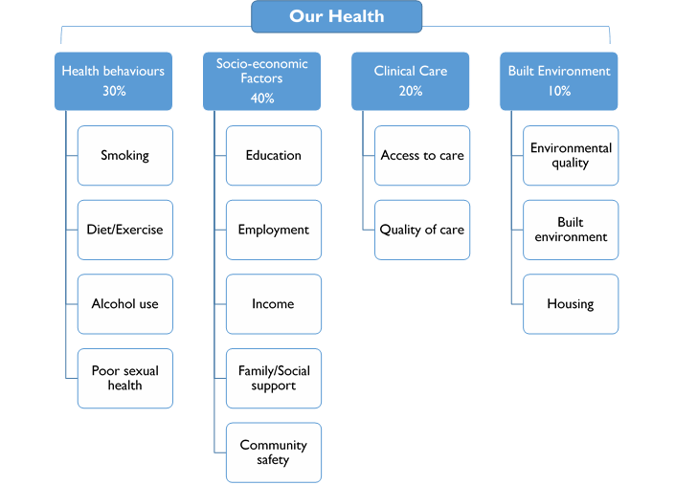

Figure 1 The range of factors which influence our health and wellbeing.

How Hart District Council can influence health and wellbeing
- Providing environments where people can be active including our green spaces and leisure centres.
- Influencing the wider determinants of health and wellbeing through our statutory functions including housing, planning, community safety and environmental health. View Hart’s Housing Strategy at www.hart.gov.uk/sites/default/files/2026-03/Housing-Strategy-2026-2031-Final.pdf
- As an enabler of high-quality communities through the Hart Local Plan
- Through the Community Partnerships and Projects team’s wider collaboration including:
  - Support to the Hampshire District Community & Wellbeing Officers Group, Hampshire County Council’s Money & Mental Health Partnership, Aldershot, Farnborough, Fleet & Yateley Mental Health Integrated Community Service Group (MHICS), and the Hampshire Place Assemblies.
  - Working jointly with Hart’s Countryside team to increase the use of green spaces by people with disabilities and others who currently don’t use our green spaces.
  - Information sharing and partnership working through our Here for Hart meetings and bulletins.
  - Focused community forums such as the Hart Carers Forum and the Hart Older Adults Forum, to identify areas of need and work collaboratively to address those needs.
  - Working together with our armed forces partners through the Hart Armed Forces Community Covenant Partnership, to understand and address issues affecting the lives of the armed forces community including serving personnel, reservists, veterans and their families
- Providing support to the voluntary and community sector, such as Hart Voluntary Action and Citizens Advice Hart, who play a vital role in improving health and wellbeing, and supporting the most vulnerable people in Hart’s communities
- Developing or supporting delivery of public health campaigns and programmes
- Helping shape and inform partnership programmes, strategies and commissioning of services

Where are we now?
- Hart’s communities generally experience good health compared to England and Hampshire as a whole. However, we know that this is not everyone’s experience and that more could be done to improve health and wellbeing in Hart’s communities.
- We are increasingly living in an uncertain and stressful environment, so we need to improve our mental health, resilience and access to mental health services.
- Pressures and demands on people’s lives mean we need to make it easier for people to make healthy choices.
- Climate changes mean we need to help support the health of our most vulnerable residents through wetter winters and hotter summers.
- Hart is the least deprived local authority in the country according to the 2025 Indices of Deprivation. However, the same data shows areas of relative deprivation in Hart.
- Life expectancy at birth in 2021-2023 was 83.4 years for men and 85.9 years for women, higher than the England and Hampshire average. Across the 51 local authorities in the South East this is the highest life expectancy for males and the second highest for females.
- Between 2023 and 2030 Hart’s population is forecast to increase by 2.9% which is lower than the forecast 5.1% change for the whole of Hampshire. The number of Hart residents aged 75 years and older is forecast to increase by 14.8% in the same time period which is also less than Hampshire as a whole (16.5%).
- In 2021-2023 the life expectancy inequality gaps between people from the most and least deprived communities in Hart were 4.3 years for men and 5.5 years for women. These inequality gaps have been increasing since 2018-2020 when they were 1.1 and 0.8 respectively.
- Although there are smaller numbers of people in Hart within specific ‘at risk’ groups compared to many other districts in Hampshire (such as those who are unemployed, experiencing addiction, homeless or living with a disability or long-term condition), those individuals may face additional challenges in accessing the support they need due to services and groups not having a physical presence in the district, and limited public transport options.
- There are two armed forces facilities in the district including RAF Odiham and Minley Station. There are also areas of armed forces housing at Church Crookham and Odiham. The 2021 census showed that 4% of people in Hart previously served in the UK regular armed forces and 0.8% previously served in the UK reserve armed forces. It is estimated that there are 1,175 veterans receiving Armed Forces Pensions in Hart. Although many of the health needs will be similar to those of the general population, there is increasing recognition that there are some specific health issues associated with service life including for families. Further information can be found at Armed forces, veterans and families | Hart District Council

Our approach to improving health and wellbeing
In order to improve the health and wellbeing of communities in Hart, we will:
- Take a Community-Centred Approach: Fostering integration and partnership working to enhance health and care services.
We will take a community-centred, collaborative approach which recognises the collective power of individuals, communities and a wide range of organisations and services, to influence health and wellbeing. Working together across the NHS, voluntary sector and local authority can help to ensure people can access the support they need from the most appropriate place and at the right time. In turn, this can help to reduce pressures on local services and ensure resources can be focused on those people with the worst health outcomes. Will also help people to find ongoing support as close to home as possible.
- Work to Reduce Inequalities: Addressing health disparities and ensuring equitable access to health services across different communities.
We will combine efforts to improve health outcomes for all residents alongside targeted interventions for those most at risk of poor health and wellbeing in order to reduce health inequalities. Using a range of available data sets, we can focus work around specific goals such as those related to mental health, physical health education or employment. Inequalities in access to information and green spaces will also be addressed as detailed in the Active Lives and Access to Support & Information sections of this plan.
- Support Education, Training and Employment in Hart: Promoting healthy workplaces and supporting employment as a determinant of health.
Unemployment has a significant impact on both physical and mental health. Access to free online training courses will be available to all residents and other information will be available to promote employment and training opportunities. Access to the internet and online training will also be publicised to those who currently lack access and / or skills.
- Address Climate Change Health Impacts: Integrating health considerations into climate action and sustainability efforts
The impacts of climate change on health and wellbeing are varied and those that are most disadvantaged will be disproportionately affected. Public Health Hampshire suggest that Hart may be most affected by flooding, extreme temperature, air quality and vector-borne disease.
Understanding who is most affected will help us communicate ways of mitigating risks and target any funding that may be available to make relevant home adaptations. Wider planning considerations can also improve climate change related health outcomes.
- Work to Increase Healthy Life Expectancy: focus on the building blocks of health across all ages and look to improve, not just the length of life, but the quality of all years of life. We will seek to help improve the health and wellbeing of people of all ages, recognising that what influences health changes as we journey through our lives and that we can take steps at any age to improve our health and that of our family. We will focus on keeping people well, preventing ill health and enabling people to be in control of their health and wellbeing.

Health and Wellbeing Priorities

As mentioned, we will address health inequalities through targeted projects as well as by giving due consideration in all our work. Focused work may be relevant to a specific age group, health condition, disability, geographical location or another specific identifier, for example if someone is a carer.

There are many ways of grouping work to improve people’s health and wellbeing. We have three focus areas which are relevant to all Hart residents regardless of age or current health and wellbeing status.

- Active lives
- Preventing poor health
- Access to support and information

Active Lives

Why?
This Public Health England data shows the clear benefits to health and wellbeing of being active. It reduces the risks of a wide range of life-threatening illnesses as well as improving people’s mental health and slowing cognitive decline.
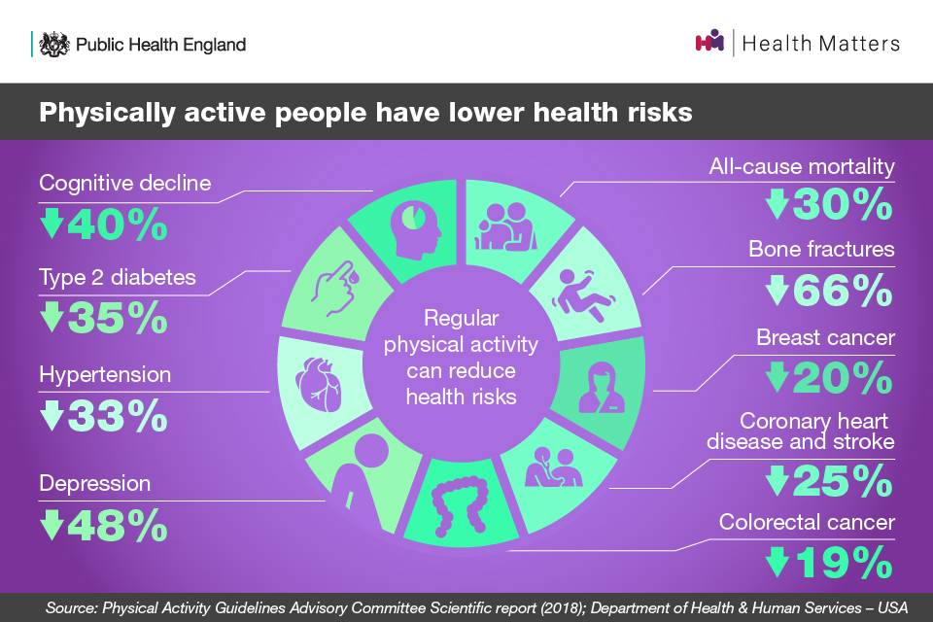

Where are we now?
In 2022/23 14.4% of Hart’s adults were inactive. This is lower than the figure for Hampshire as a whole (19%) and Hart’s level has stayed roughly the same since 2016. However, since 2016 the percentage of adults in Hart cycling for travel at least three days a week has been steadily dropping.
For some residents the cost of some exercise options is a barrier as well as lack of access to transport. We also know that carers are much less likely to be active compared to all adults, despite wanting to do more exercise. People with a disability are also twice as likely to be physically inactive than those without a disability.
The 2024 Hampshire #BeeWell report surveyed 1,732 secondary schoolchildren in Hart about their health and wellbeing. Of those surveyed, 37.4% took part in one hour or more physical activity a day. Government activity guidelines say that 5-18-year-olds should be getting at least an hour of moderate to vigorous physical activity a day.
In summary, Hart’s residents are fairly active but there are a lot of people getting little or no exercise which increases their risk of poorer physical and mental health. Hart has an aging population so helping residents keep active into older age will reduce the risks of dementia, falls and illness, and keep people independent and living in their own homes for longer.

What are we going to do?
– work with exercise providers to ensure a wide range of exercise options are available to residents of all ages and abilities. If there are gaps in service we will work to fill that gap.
– promote the benefits of exercise and educate about the risks of being inactive to residents as well as people who work with residents.
– ensure activities at community venues are well promoted to encourage local people to attend.
– use physical information, e.g. leaflets, and word of mouth to publicise available activities rather than relying on digital media which will exclude some people.
– make green spaces accessible and usable for a range of physical activities, as detailed in the Countryside Events and Education plan.
– promote and support Health Walks on our countryside sites, including dementia-friendly walks.
– encourage active transport, i.e. walking and cycling, and increase available routes as detailed in Hart’s Local Cycling and Walking Infrastructure Plan.

Data Sources
- Hampshire JSNA - Healthy Lives Report - Exercise and physical activity
- #BeeWell Neighbourhood Data Hive
- Physical activity guidelines for children and young people - NHS
- Carers_UK-carers-and-physical-activity-report.pdf
- Disabled people | Sport England
- Local Cycling and Walking Infrastructure Plan | Hart District Council

Preventing Poor Health

Why?
From pregnancy right through to older age, preventing poor health improves people’s quality of life and reduces inequalities. There are many health conditions that are preventable and there are lots of ways they can be prevented or reduced.
Here are some examples.
Money and Mental Health: good health means people are more likely to be employed and financially independent and less likely to struggle with depression and anxiety as a result. This also works the other way round as people experiencing mental health problems are three and a half times more likely to be in problem debt than people without mental health problems.
Exercise: we have seen in the Active Lives section how exercise can reduce the risk of a lot of health conditions.
Dementia: studies into dementia show that up to 45% of dementia cases could be prevented or delayed. Some of the preventable risk factors include less education, hearing loss, high LDL cholesterol, social isolation and depression.
Childhood obesity: overweight and obesity in childhood are associated with an increased risk of overweight and obesity in adulthood, and earlier onset of preventable illnesses such as Type 2 diabetes and cardiovascular diseases. It also increases the risk of asthma in childhood.
Smoking and excessive alcohol consumption: both increase the risk of cancer as well as increasing the risk of heart disease and dementia. They each also increase the risk of a range of other health problems such as stroke and lung disease (smoking) and liver disease and mental health problems (alcohol).

Where are we now?
Disability and long term-health conditions: in the 2021 census Hart had the country's third lowest proportion of residents who were identified as being disabled and limited a lot (4.2%). Of the female population in Hart, 4.5% of females described themselves as having a long-term health problem or disability which limited their day-to-day activities a lot, compared to 3.8% of males.
Employment: in the 12 months ending in Q4 2024, there were 71.3% of Hart’s population, aged 16-64, in employment. This is very close to the Hampshire figure of 71%.

Mental health: in 2022 / 23 there were 12,298 people in Hart registered with depression, which is over 14% of the adult population.
Debt: Citizens Advice Hart statistics show that in Q4 2024/25 they saw an increase of 8% on 2023 Energy and Debt related issues. The number of cost-of-living related issues also increased by 12% compared to Q3, and by 182% compared to the same period in 2022/23
Dementia: as many people with dementia are undiagnosed it is difficult to say how many people are living in Hart with the condition. According to Alzheimer’s Research UK, 24,000 people living in Hampshire were diagnosed with dementia in 2020. As risk of dementia increases with age, as do preventable factors such as sight and hearing loss, there will be more of Hart’s population with dementia in the future if all other factors stay the same. This is because Hart has an ageing population.
Overweight or obese children: in 2023/4 the percentage of children in reception year at school who were overweight (including obese) was 19.7% which is similar to the Hampshire figure of 21.5%. In year 6 this figure is 25.2% which is lower than the Hampshire figure of 32.4%. However, this still represents a quarter of year 6 children in Hart who are overweight or obese.
Smoking and excessive alcohol consumption: according to the 2023 Annual Population Survey, 6.8% of Hart’s adult population were self-reported smokers, which is the second-lowest percentage in Hampshire. However, in 2022 nearly 20% of adults in Hart with routine or manual jobs were smokers. In 2023 there were 1,297 hospital admissions per 100,000 of Hart’s population for (broad) alcohol-related conditions. Significantly more were men than women.

Falls and bone fractures: falls are the largest cause of hospital admissions for older people and are a major factor for people moving into long-term nursing or residential care. Only 1 in 3 people suffering from a hip fracture return to their former levels of independence and 1 in 3 ends up leaving their own home and moving to long-term care. In 2022 there were 360 emergency hospital admission due to falls in the over 65s. In 2023/4 there were 100 hip fractures, 70 of which were in people aged 80 or over.
In summary, if we compare Hart health statistics to the rest of Hampshire, or the rest of England, then our residents’ health is very good. However, many health statistics for Hart show that the number of residents with preventable health conditions or situations that can cause poor health is increasing, e.g. debt, dementia and overweight children.
What are we going to do?
Debt and social circumstances
- seek to prevent and address the social circumstances that can result in people being more vulnerable to poor health and wellbeing such as homelessness and domestic abuse, working collaboratively through forums such as the Northeast Hampshire Domestic Abuse Forum.
- continue to fund Citizens Advice to provide debt advice and budgeting training to residents.
- produce Cost of Living Bulletins to share ways that residents can get local help and support with cost-of-living pressures.
- promote relevant information available on the Here for Hart Directory to support those in or at risk of being in debt.
- use local data to support community work in more deprived areas.

Dementia
- keep up to date Hart dementia support information, online and in printed format: Dementia support | Hart District Council
- work with Hart’s Older Adults Forum to build best practice for sharing dementia prevention information / interventions.
Healthy weight / smoking / alcohol
– promote Hampshire County Council’s services and promotional campaigns.
- share local support for smoking cessation and alcohol and drug addiction through the Here for Hart Directory: Here for Hart Directory | Healthy Lifestyles Support
- encourage active lifestyles, including green grid and Edenbrook bike park promotion, to reduce the risk of obesity.

Employment and training
- work with DWP to hold an annual employment fair in Hart.
- offer free online training to Hart employers and residents via SEEDL
- share local employment, skills and volunteering opportunities through the Here for Hart Directory: - offer volunteering opportunities with Hart’s Countryside team.

Disability and long-term health conditions
- work more closely with Hart occupational health team to understand the challenges of residents who need extra support.
- use Here for Hart forums to shape collaborative goals and agree on specific actions.
- make new connections with local groups which support disabled residents in Hart, to better understand their needs.
- improve access to our green spaces in Hart, as detailed in the Countryside Events and Education Plan.

Mental health
- share information about local mental health support groups & projects to residents and local mental health teams.
- take a broad approach to ways of improving people’s mental health, eg increasing access to exercise, improving employment opportunities, reducing social isolation. Helping with debt and housing.
- where funding is available, we will support projects and organisations that help those with poor mental health.

Falls prevention
- support Hampshire County Council’s Live Longer Better Programme.
- improve access to exercise for older adults.
- consult with Hart Older Adults Forum and the occupational therapy team to understand how we can effectively collaborate on reducing falls in Hart.

Data sources
- NHS England » About the prevention programme
- Rising ill-health and economic inactivity because of long-term sickness, UK - Office for National Statistics
- Money and mental health facts and statistics
- Risk factors for dementia
- Children's overweight and obesity - NHS England Digital
- Home - Office for National Statistics (ons.gov.uk)
- Home | LG Inform (local.gov.uk)
- CA cost of living data dashboard
- Hampshire JSNA-Microsoft Power BI – alcohol & smoking data
- Microsoft Power BI – Hampshire JSNA – falls / hospital admission data
- Public Health Profiles – falls / fractures data

Access to Support & Information

Why?
We are lucky in Hart that we have a wide range of support groups and information services to help our residents with their health and wellbeing. On Hart District Council’s Here for Hart Directory), there are over 500 such entries. We understand, however, that for those who are online there is an ongoing need to promote sources of information with a range of targeted promotions, to appeal to different groups of people with different needs.
For those residents who aren’t online, or who don’t know how to use the internet, the lack of access to information, support and vital services, such as GP appointments and banking, can be an enormous problem. Research shows that digital exclusion can negatively impact people in terms of earnings, employability, social connectedness and available time.
We recognise that as well as ensuring residents have access to the necessary support and information it is also key that organisations that work with them also understand what is available. This way people such as healthcare workers, council staff and community volunteers are well placed to signpost residents to the local support and information that is most fitting for their needs.

Where are we now?
It is estimated that there are over 80,000 Hart residents over the age of 18. However, over the 12 months to May 2025, there were, on average, only 513 monthly users of the Here for Hart Directory. Although lots of people use social media groups and search engines to find information, we know that there are still a lot of people just finding out about the directory and how useful it can be for them.
We promote the Here for Hart Directory, national and regional health campaigns and green spaces via social media, print ads and council publications. While we track engagement, impact is harder to measure. Materials include Hart News, Here for Hart bulletins and adverts in local magazines and hospital publications.
Our collaboration with local health partners means that we promote health and wellbeing organisations and services in local meetings such as those for Fleet and Yateley’s mental health integrated care service, Here for Hart meetings, and Carers and Older Adults Forums. Partnership working with GP surgeries in Hart results in our health and wellbeing promotions appearing on surgery electronic noticeboards.
The Council’s communications team work to make the website as accessible as possible: Accessibility | Hart District Council and to use a wide range of methods of communication: How we communicate with you | Hart District Council There is ongoing improvement of the website as well as staff training around areas such as plain English and creating accessible documents.
Although there are no reliable statistics about the number of residents in Hart who are digitally excluded and / or illiterate we do have some wider information. Across the UK, 9% of adults struggle to afford mobile and 8% struggle to afford broadband. 16% of adults lack the Foundation-level essential digital skills (Good Things Foundation, 2024). According to a Citizens Advice Hampshire, a 2024 report said the largest groups coming for support who reported digital exclusion are older adults and those with long-term health conditions. The Literacy Trust reports that in 2024 in England 1 in 6 adults aged 16-65 have very poor literacy skills. Age UK research suggests that 25% of people aged 65 and over in the UK don’t use the internet and the main reasons are a lack of skills, a lack of trust in the internet and a lack of adequate equipment and / or the internet.

In summary, there is a lot of health and well-being support available to Hart residents, but we recognise that not everyone is able to access that information. These people may be missing out on ways to improve their health and well-being and reduce social isolation. Digital exclusion has wider implications. It is also difficult to measure the impact of health promotions due to lack of evidence as to who took action after seeing specific messages.

What are we going to do?

Here for Hart Directory
- following a recent usability review, we will improve the look and feel and user experience on the Here for Hart Directory.
- we will widely promote it using online and non-digital methods of communication.
- we will continue to look into ways of providing focused snapshots of content to certain user groups, e.g. health care workers and schools.

Accessibility
- continue to make our online content as accessible as possible.
- offer printed copies of online content and digital newsletters.
- continue our learning about accessibility needs of our residents and respond accordingly.
- work to better understand how people access information and adjust our engagement strategies where appropriate.

Digital inclusion
- help for digitally excluded residents, for example to fill in forms, will continue to be available via the Council’s reception team.
- the Council’s core funding of Citizens Advice Hart will continue which will help support digitally excluded residents.
- where there are opportunities, we will work with other community organisations to support digital inclusion projects.
- promote local digital inclusion projects such as library drop-ins and Lions refurbished devices scheme.
- look into providing digital security and scam avoidance training to older adults.
- audit current digital training and free device offerings in Hart. Then publicise the results to those in need, as well as those who work and volunteer with them.

Data sources
-Hampshire JSNA Microsoft Power BI – 2024 based estimates: age of population
- Exploring the UK’s digital divide - Office for National Statistics
- Adult Literacy Rates in the UK | National Literacy Trust
- What We Know About Digital Inclusion | Good Things Foundation
- Helping older people improve their digital skills | Age UK

